Real-Time Surveillance Weapon & Anomaly Detection System
Final Year Project Proposal
Session Fall 2026



Department of Computer Science
National University of Computer and Emerging Sciences, Karachi Campus
18th September 2026

Project Registration
Project ID (for office use)
Type of project |  |  | [✔ ] Traditional [ ] Industrial [ ] Continuing
Nature of project |  |  | [✔] Research & Development [ ] Research [ ] Research
Sustainable Development Goals(SDGs) |  |  | [ ] Good Health and Well-Being [ ] Quality Education  [✔] Industry, Innovation, and Infrastructure [ ] Gender Equality  [ ] Decent Work and Economic Growth [ ] Climate Action
Area of specialization |  |  | [✔] Artificial Intelligence (AI) [ ] Data Science and Analytics  [ ] Internet of Things (IoT) [ ] Blockchain  [ ] Mobile App Development [ ] Web Development [ ] Cybersecurity  [ ] Game Development [ ] Natural Language Processing (NLP)  [ ] Other
Project Group Members
Sr.# | Reg. # | Student Name |  | CGPA | Email ID | Phone # | Signature
(i) | 23K-0784 | Muddassir Rizwan |  | 3.24 | k230784@nu.edu.pk
(ii) | 23K-2061 | Faiz Hussain |  | 2.92 | k232061@nu.edu.pk
(iii) | 23K-2075 | Qaim Mehdi |  | 2.37 | K232075@nu.edu.pk
Declaration: FYP group members have cleared all prerequisite courses For FYP-I as per their degree requirements.

- Project Abstract
Modern video surveillance networks are widely deployed across urban environments, yet they function predominantly as passive recording infrastructure requiring continuous human monitoring. Security operators suffer from rapid cognitive fatigue, missing over 90% of real-time security threats within just 20 minutes of active observation. Furthermore, existing automated threat detection systems address only static weapon identification, leaving a critical research gap in recognizing dynamic violent crimes where weapons are absent. To bridge this gap, this project presents SENTINEL, an end-to-end AI-powered real-time surveillance framework that unifies weapon detection and temporal human action recognition into a single automated pipeline. SENTINEL executes two concurrent inference tasks on live CCTV feeds: frame-level detection of guns and knives utilizing a fine-tuned YOLOv8 object detector, alongside pose-based temporal crime classification using YOLOv8-Pose skeletal key point extraction fed into a lightweight LSTM classifier to identify critical crime behaviours including fighting, robbery, and shooting. To mitigate false alarms caused by momentary visual noise (e.g., a smartphone briefly resembling a firearm), SENTINEL employs a sliding-window temporal buffer that requires threat detections to persist across multiple consecutive frames before triggering an alert. This project expects to achieve over 25 frames per second with sub-second alert latency, transforming passive surveillance into an automated threat detection system while maintaining high precision through temporal false-alarm suppression.
Keywords: Crime Detection, Smart Surveillance, Deep Learning, Object Detection, Temporal Behaviour analysis, Long Short-term Memory
- Introduction
The research domain of this project lies at the intersection of Computer Vision, Deep Learning-Based Object Detection, and Spatio-Temporal Human Action Recognition applied to intelligent video surveillance systems.
Public safety and urban security are among the most critical challenges facing modern societies. According to the World Health Organization, interpersonal violence accounts for over 475,000 deaths annually, with countless more incidents of assault, robbery, and theft going undetected or detected too late for intervention. Closed-circuit television (CCTV) surveillance networks have been deployed worldwide to deter and document criminal activity, yet the overwhelming volume of video data generated by these networks far exceeds the capacity of human monitoring personnel.
Currently, most CCTV infrastructure functions as a passive post-incident forensic tool. Security footage is typically reviewed only after a crime has been reported, rendering the surveillance system reactive rather than preventive. This means that crimes committed without a visible weapon (physical assault, snatching) go entirely undetected by existing solutions.
Recent advances in real-time object detection (YOLO family), human pose estimation (skeletal key point extraction), and lightweight recurrent neural networks (LSTMs) have made it computationally feasible to perform multi-modal video understanding at interactive frame rates on consumer-grade GPU hardware. These technological enablers create an unprecedented opportunity to transform passive surveillance infrastructure into intelligent, proactive threat detection platforms capable of autonomously identifying both weapon-based and behavioural crime anomalies in real time.
- Literature Review
Automating threat detection in surveillance environments has drawn considerable research attention, spanning human operator limitations, weapon detection, behavioral action recognition, temporal filtering, and benchmark dataset development. Studies in surveillance psychology report a vigilance decrement of approximately 45% within the first 20 minutes of continuous CCTV monitoring, with missed-event rates nearing 90% during extended shifts [1], motivating the shift toward automated detection systems.
In weapon detection, Bonde et al. (2025) combined YOLOv8 with a secondary CNN verifier and multi-channel alerting, achieving 96% accuracy, but without behavioral analysis and evaluated only on internet images rather than real CCTV footage [2]. Shanthi and Manjula (2026) proposed a CNN–Transformer hybrid performing simultaneous weapon detection and facial recognition at high accuracy, though it requires high-end GPUs and performs only static frame-level analysis with no temporal modeling [3].
Addressing the temporal dimension, Praveen and Sandeep (2025) combined YOLOv8 with optical flow and an Isolation Forest classifier, using a 30-frame temporal consistency buffer that reduced false positives by 23.4% [4] a concept that directly informs SENTINEL's false-alarm suppression. For action recognition, Elnady and Abdelmunim (2025) showed that bounding-box trajectory vectors through a lightweight 2-layer LSTM achieve 96–100% accuracy at an ultra-lightweight footprint, though coarse bounding-box features lose fine-grained skeletal detail [5] the limitation SENTINEL addresses by using 17-joint YOLOv8-Pose key points instead.
Most closely aligned with SENTINEL, Reddy et al. (2026) combined YOLOv8 with a CNN-LSTM classifier across four crime classes, achieving 94.8% accuracy, but with added pipeline latency, vague dataset documentation, and no operational delivery such as dashboards or alerts [6].
SENTINEL's benchmark datasets are themselves significant research contributions: Sultani et al. (2018) introduced UCF-Crime, a large-scale weakly-supervised surveillance dataset across 13 anomaly categories [7], and Cheng et al. (2020) introduced RWF-2000, a balanced fight/non-fight dataset drawn exclusively from real CCTV footage [8]. Broader related work includes pose-based crime prediction for indoor shoplifting [9], surveys highlighting persistent challenges in deep learning-based crime detection [10], and optimized YOLOv8 deployments that lack temporal behavioral modeling [11].
Collectively, no existing system unifies multi-class weapon detection, pose-based temporal behavior classification, algorithmic false-alarm suppression, and real-time operational delivery within a single pipeline the gap SENTINEL is designed to bridge.
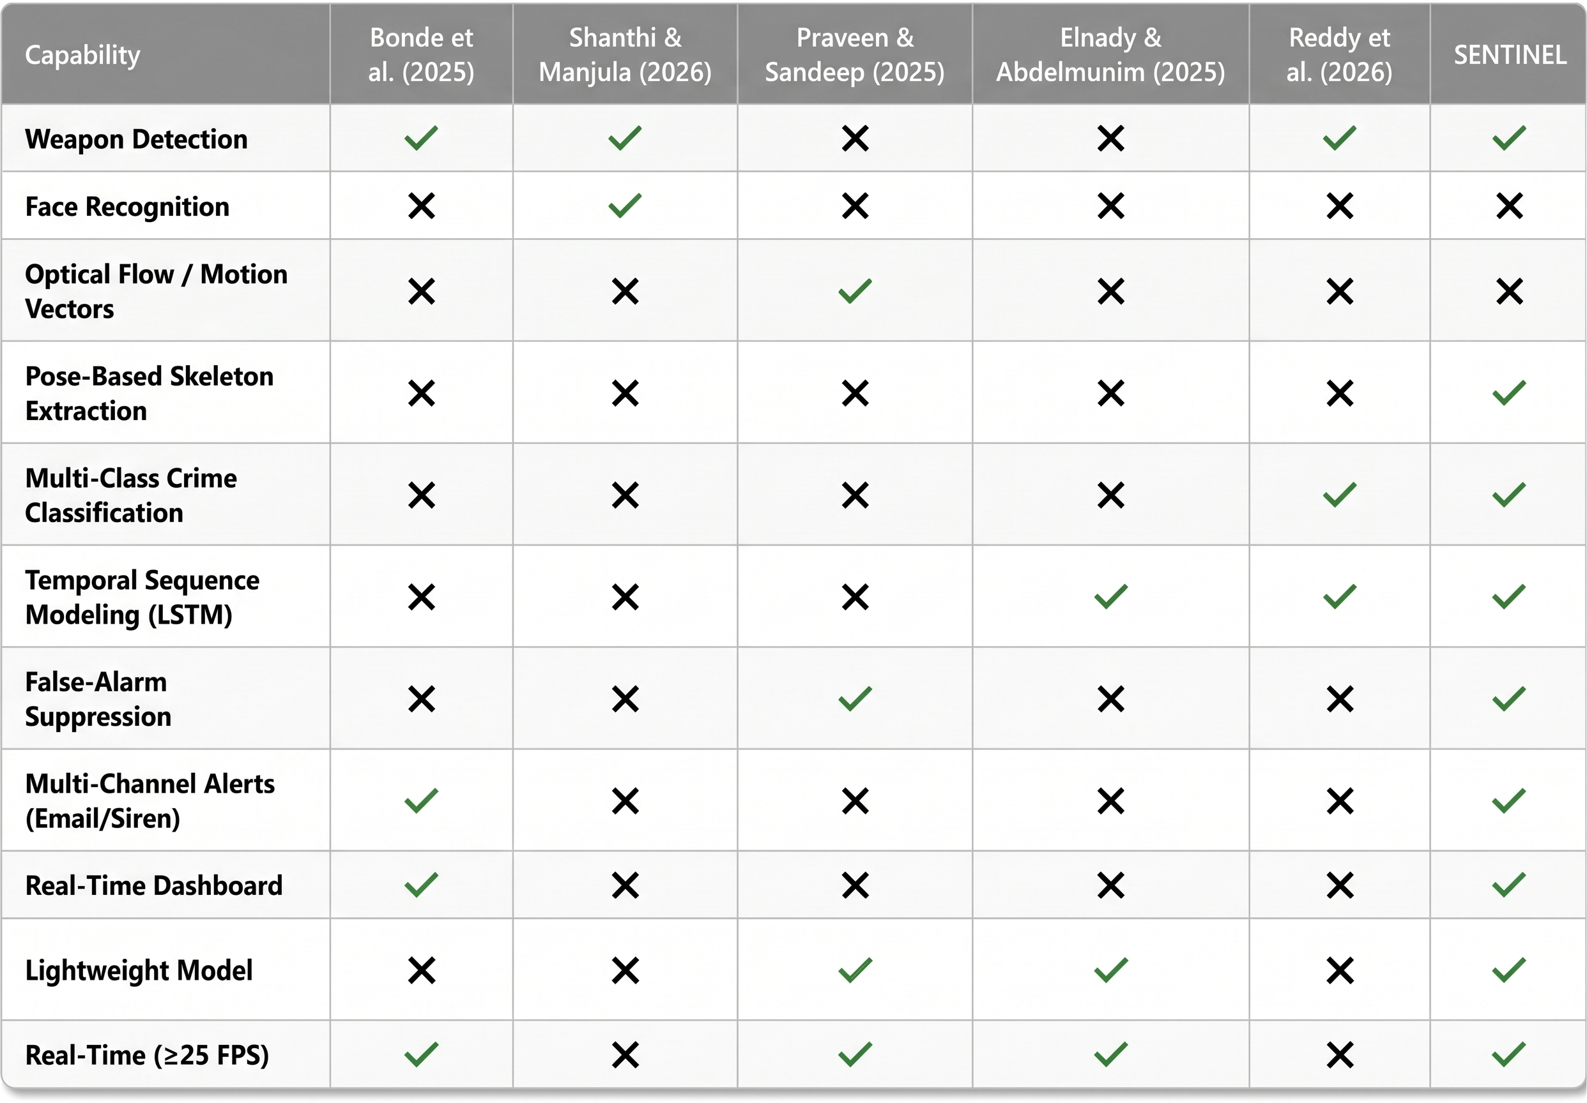
Figure 1. Capability Matrix — Comparative analysis of surveyed literature
- Problem Statement
Existing real-time video surveillance systems suffer from three fundamental and interconnected deficiencies:
Human Operator Cognitive Overload: Studies in surveillance psychology demonstrate that human CCTV operators experience significant performance degradation after 20 minutes of continuous monitoring, resulting in a missed-event rate exceeding 90% during extended shifts. This renders human-dependent monitoring operationally unreliable for time-critical threat detection.
Static Object Detection Blindness: Current AI-based surveillance solutions detect the presence of weapons in isolated frames. However, they are architecturally incapable of recognizing dynamic criminal behaviours physical assault (fighting), street robbery, or active shooting scenarios where behavioural context across time is required for accurate classification. This creates a critical detection gap for most urban violent crimes.
Excessive False Alarm Rates: Single-frame detection models frequently misclassify benign objects (smartphones, wallets, umbrellas) as threats due to visual similarity, generating alarm fatigue that causes operators to ignore genuine alerts. No temporal validation mechanism exists to distinguish momentary visual noise from persistent, confirmed threats.
Research Gap: There exists no unified, real-time surveillance system that simultaneously performs weapon detection, temporal behavioural crime classification, and algorithmically validated false-alarm suppression within a single deployable pipeline operating at interactive frame rates on accessible hardware.

RQ1: How effectively can a unified pipeline combining weapon detection with pose-based action recognition classify violent crimes in real-time surveillance footage?
RQ2: To what extent do skeletal key point features improve temporal crime classification accuracy compared to traditional bounding-box-based approaches?
RQ3: How does the implementation of a sliding-window temporal buffer impact false-positive suppression rates in real-time threat detection?
RQ4: Can a dual-model AI inference pipeline sustain real-time throughput (≥25 FPS) on consumer-grade GPU hardware?
- Motivation
The motivation behind this project is to develop a practical, deployable, real-time intelligent surveillance solution that transforms passive CCTV infrastructure into an active crime detection and alerting platform. Specifically, the project aims to eliminate dependence on human operators by automating continuous 24/7 threat monitoring, removing the cognitive bottleneck caused by human fatigue-induced performance degradation. It also seeks to bridge the weapon-only detection gap by extending beyond static weapon identification to recognize behavioural crime patterns such as fighting, robbery, and shooting that constitute the majority of urban security incidents.
In addition, the project aims to algorithmically suppress false alarms by implementing a temporal consistency buffer that validates detections across consecutive frames, thereby dramatically reducing operator alarm fatigue. It further aims to provide actionable situational awareness by delivering instant, multi-channel alerts including dashboard siren, email with snapshot, and database audit logging to security personnel for rapid incident response. Finally, the project aims to ensure accessibility by designing the system to operate at real-time speeds on consumer-grade hardware, making intelligent surveillance accessible.
- Aims and Objectives
To design, implement, and evaluate an end-to-end intelligent real-time video surveillance system that unifies weapon detection with temporal behavioural crime classification and automated alert dispatch.
Objectives:
The primary objective of this project is to fine-tune a YOLOv8 object detection model on curated weapon datasets to accurately detect and localize guns and knives in live video frames. In parallel, the project aims to implement YOLOv8-Pose for human skeletal key point extraction, capturing 17 body joint coordinates per detected person per frame. These key point trajectories will then be processed through a lightweight LSTM-based temporal action classifier, which will be designed and trained to classify sequential movement patterns into three crime categories (Fighting, Robbery, and Shooting) alongside a normal class, resulting in a 4-class output.

To improve reliability, a sliding-window temporal consistency buffer will be developed to suppress false alarms with zero additional computational overhead. The system will further be supported by an asynchronous backend, built with WebSocket-based live video streaming and incident event broadcasting, enabling real-time data flow between detection and monitoring components. A real-time monitoring dashboard will also be developed, featuring Canvas-based bounding-box overlay, audible siren alerts, and incident history browsing, allowing security personnel to review both live and past events.

For accountability and evidence retention, a persistent incident audit database will be implemented to store timestamped snapshots, threat classification, and confidence scores for every confirmed event. This will be complemented by automated email alerting, which will dispatch incident notifications containing the threat-type classification along with a snapshot image attachment. Finally, the system's performance will be evaluated on standard benchmarks, with results reported in terms of Accuracy, Precision, and Recall.

- Scope of the Project
In-Scope
- Single-stream real-time video ingestion.
- weapon detection: Guns and Knives (2 classes).
- 3-class behavioural anomaly classification + Normal: Fighting, Robbery, Shooting.
- Pure temporal consistency buffer for false-alarm suppression.
- Real-time web-based operator dashboard with live video stream, canvas-rendered bounding boxes,
- audible alarm and incident history.
- Incident database audit trail (timestamp, snapshot image, threat class, confidence score).
- Automated email alert dispatch with incident snapshot attachment.

Out-of-Scope
This project excludes multi-camera cross-camera re-identification, real-time facial recognition, and audio-based acoustic threat detection, as these require different sensor modalities or capabilities beyond the current dataset. Concealed weapon detection is also excluded, since it requires X-ray or millimeter-wave hardware rather than a camera-based approach. Edge hardware deployment (e.g., Jetson Nano/Raspberry Pi optimization) is likewise out of scope for this phase.

- Proposed Methodology
Dataset Collection & Preparation
Weapon Detection: We will construct a unified custom dataset by merging two distinct Kaggle sources: 'Weapon Dataset for YOLOv5' and 'Weapon Detection for YOLO'. This combined dataset will be standardized into our required 2-class architecture (Guns and Knives) and will incorporate negative-sample images to effectively reduce false-positive detections during real-time inference.

Action Recognition: We will curate a customized dataset for temporal action classification by extracting specific subsets from two sources: the UCF-Crime dataset and the RWF-2000 dataset. From UCF-Crime's 13 categories, only clips relevant to our scope (Fighting, Robbery, Shooting) will be filtered. These will be supplemented with RWF-2000's 'Fight' sequences (added to the Fighting class) and 'Non-Fight' sequences (used to populate the Normal class), together constructing a unified 4-class dataset (Fighting, Robbery, Shooting, Normal).

Weapon Detection Model Training (YOLOv8s)

Fine-tune YOLOv8s (Small) (pre-trained on COCO) on our unified custom weapon dataset (2-class: Gun, Knife). The Small variant is selected for its optimal balance between detection accuracy and real-time inference speed.

Human Pose Estimation (YOLOv8m-Pose)
Deploy pre-trained YOLOv8m-Pose (Medium) model (COCO-Pose weights) to extract 17 skeletal joint key points (x, y, confidence) per detected person per frame. The Medium variant is specifically selected to counteract the accuracy degradation caused by top-down viewing angles and partial occlusions typical in CCTV surveillance footage.

Temporal Action Classifier Training (LSTM)
The skeletal key point data extracted by YOLOv8m-Pose will be organized into sequences of 30 consecutive frames, forming a 1-second observation window per sample. Each frame contributes a 51-dimensional feature vector derived from the 17 detected body joints. These sequences will be used to train a 2-layer LSTM network, producing a 4-class output: Fighting, Robbery, Shooting, and Normal.

Temporal Consistency Buffer (False-Alarm Filter)
To suppress false alarms caused by momentary visual noise (e.g., a smartphone briefly resembling a weapon), a global scene-level sliding window buffer will be maintained over the most recent detection and classification outputs. A threat alert is confirmed only when consistent detections persist across multiple consecutive frames within the buffer window.

Backend & API Development
An asynchronous backend will be developed to orchestrate the entire system. A dedicated video capture thread using OpenCV will continuously feed frames into the AI inference pipeline. The backend will expose RESTful API endpoints for incident retrieval, system status monitoring, and configuration management. A WebSocket server will be implemented to enable real-time processed frame streaming and instant alert broadcasting to all connected dashboard clients.

Frontend Dashboard
A single-page surveillance monitoring application will be built. The backend will stream each processed frame along with its detection metadata (bounding box coordinates, threat class, confidence scores) as JSON over WebSocket. The frontend will render bounding boxes and key point skeletons client-side using the HTML5 Canvas API. The dashboard will also integrate audible alarm notifications on threat detection, a visual alert banner displaying the active threat classification, and a searchable incident history table for reviewing past events.

Integration & End-to-End Testing
All components will be connected into a single working pipeline from camera input through to dashboard output. The system will be evaluated both quantitatively using benchmark test datasets and qualitatively through live webcam demonstrations. Key performance metrics including Precision, Recall, F1-Score, real-time FPS will be measured and reported.

Functional Requirements
Table 1. Functional Requirements
ID | Requirements
FR-01 | System shall ingest real-time video.
FR-02 | System shall detect and localize guns and knives with bounding boxes and confidence scores.
FR-03 | System shall extract human skeletal key points (17 joints) for each detected person.
FR-04 | System shall classify behavioral anomalies into 3 crime categories: Fighting, Robbery, Shooting (+ Normal).
FR-05 | System shall apply temporal consistency filtering before confirming threat alerts.
FR-06 | System shall display live video feed with real-time bounding box overlays on a web dashboard.
FR-07 | System shall trigger an audible alarm and visual alert banner upon confirmed threat detection.
FR-08 | System shall log every confirmed incident to the database with timestamp, snapshot image, threat class, and confidence.
FR09 | System shall dispatch automated email alerts with incident image attachment upon threat confirmation.
FR-10 | System shall provide an incident history view with search and filter functionality.

Non-Functional Requirements
Table 2. Non-Functional Requirements
ID | Requirements
NFR-01 | System shall process video at ≥25 FPS (target: 30 FPS) for smooth real-time operation.
NFR-02 | System shall operate on consumer-grade GPU hardware.
NFR-03 | Dashboard UI shall be accessible via modern web browsers.

- System Architecture
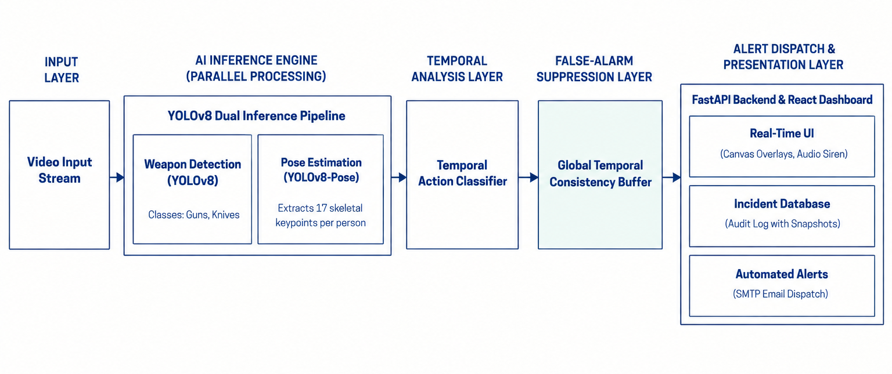
Figure 2. System Architecture
- Individual Tasks

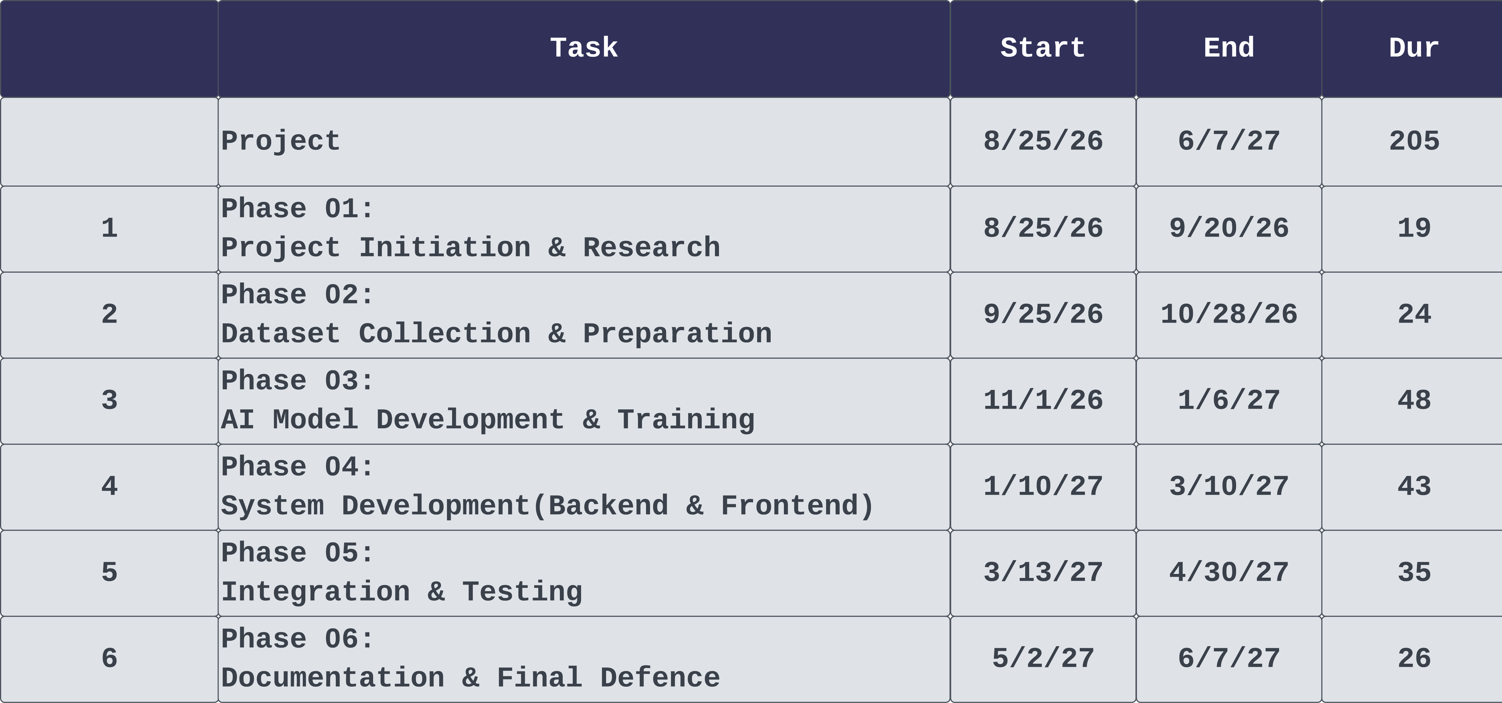
Figure 3. Project Schedule - Phase wise task breakdown

- Gantt Chart
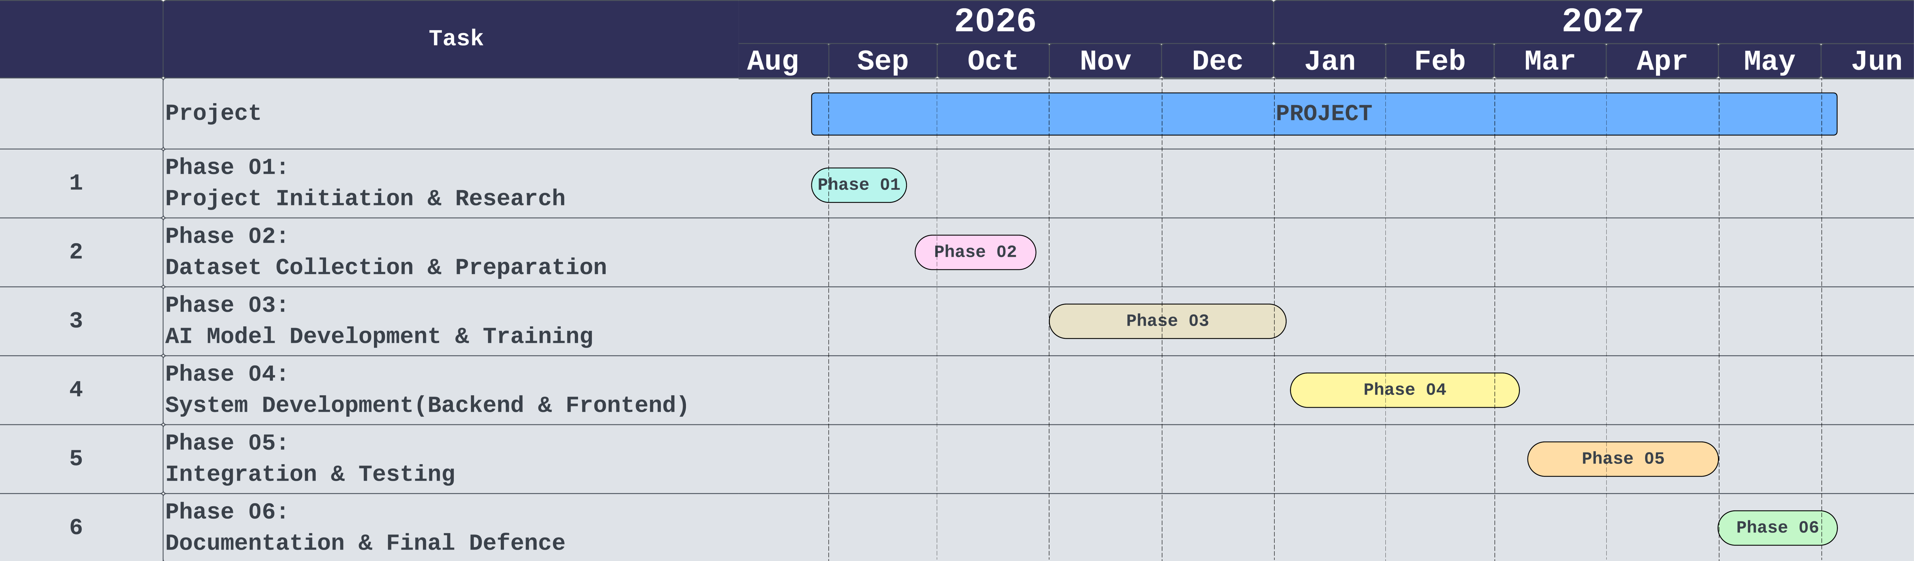
Figure 4: Gantt Chart

- Tools and Technologies
Table 3. Tools and Technologies
Category | Tool/Technology | Purpose
Programming Language | Python | AI models, backend API, data processing
Programming Language | JavaScript | Frontend dashboard UI
Deep Learning Framework | PyTorch | Model training, inference, GPU acceleration
Object Detection | Ultralytics YOLOv8 | Weapon detection & human pose estimation
Sequence Modelling | LSTM (PyTorch) | Temporal action classification
Computer Vision | OpenCV | Video capture, frame preprocessing, image I/O
Backend Framework | FastAPI | Async REST API, WebSocket server
Frontend Framework | React + Vite | Single-page surveillance dashboard
Canvas Rendering | HTML5 Canvas API | Real-time bounding box overlay
Database | SQLite / PostgreSQL | Incident audit log storage
Email Integration | Python smtplib / Gmail SMTP | Automated email alerts with image attachment
Version Control | Git + GitHub | Source code management & collaboration
IDE | VS Code | Development environment
- Expected Deliverables
Trained YOLOv8 Weapon Detection Model: Fine-tuned weights (.pt) for 2-class weapon localization (Gun, Knife) with documented training metrics.
Trained LSTM Action Classifier Model: Lightweight temporal classifier (.pt) for 4-class (Fighting, Robbery, Shooting, Normal) crime behaviour recognition with documented evaluation metrics.
SENTINEL Backend Application: Complete Python Fast API server with video ingestion, real-time AI inference pipeline, temporal buffer, WebSocket streaming, REST API, and email dispatch.
SENTINEL Dashboard: React-based single-page web application with live video monitoring, canvas bounding-box overlays, alert notifications, and incident history browser.
Incident Database: Structured audit trail of all detected events with timestamps, classification, confidence scores, and snapshot images.
Evaluation Report: Quantitative performance analysis (Precision, Recall, F1, FPS) on benchmark datasets and live demonstration.
FYP Thesis/Report: Complete academic documentation of the research, methodology, implementation, results, and conclusions.
Live Demonstration: Working end-to-end system demo using webcam feed showing real-time threat detection and alert dispatch.

References

[1] | U. N. P. S. A. (NPSA), "CCTV Operator Performance and Vigilance Decrement," Security Guidance Series, 2009.
[2] | V. Bonde, A. Choudhari, V. Baviskar, T. Mohota, T. DharamThok and S. Doke, "GuardVision: An Enhanced Weapon Detection Using Computer Vision with Alert Mechanism," Journal of Emerging Technologies and Innovative Research (JETIR), vol. 12, no. 1, 2025.
[3] | P. Shanthi and V. Manjula, "An Efficient Hybrid CNN-Transformer Framework for Real-Time Weapon Detection and Face Recognition (ConViDeTR)," Frontiers in Artificial Intelligence, vol. 9, 2026.
[4] | P. M. N and D. Sandeep, "Anomaly Detection in Video Surveillance Using YOLOv8," International Journal for Research in Applied Science & Engineering Technology (IJRASET), vol. 13, no. VIII, 2025.
[5] | M. Elnady and H. E. Abdelmunim, "A Novel YOLO LSTM Approach for Enhanced Human Action Recongnition in Video Sequences," Scientific Reports (Nature Portfolio), vol. 15, 2025.
[6] | T. D. Reddy, M. S. Sowndharya, S. M. Reddy, T. P. Kumar and S. Naveen, "Intelligent Weapon Detection System for Real Time Surveillance Using Deep Learning with YOLOv8," International Journal of Novel Research and Developement (IJNRD), vol. 11, no. 5, 2026.
[7] | W. Sultani, C. Chen and M. Shah, "Real-World Anomaly Detection in Surveillance Videos," in Proc. IEEE/CVF Conference on Computer Vision and Pattern Recognition (CVPR), 2018.
[8] | M. Cheng, K. Cai and M. Li, "RWF-2000: An Open Large Scale Video Database for Violence Detection," in Proc. 25th International Conference on Pattern Recognition (ICPR), 2021.
[9] | S. Kilic and M. Tuceryan, "Pre-Crime Detection Using Pose-Based Behavioral Analysis in 3D Convolutional Networks," International Journal of Computer Vision and Image Processing, 2023.
[10] | R. Pisati, R. Astya and P. Chauhan, "A Comprehensive Review of AI-Based CCTV Crime Detection: Methods, Challenges, and Future Directions," International Journal of Computing and Digital Systems, 2024.
[11] | P. Sharma and e. al., "Automated Crime Scene Analysis Using Optimized YOLOv5 for Real-Time Object Detection," in International Conference on Intelligent Systems and Applications, 2024.

